**Project 1:Deploying a website on AWS EC2 Instance**

* **VPC created as karthik-VPC**

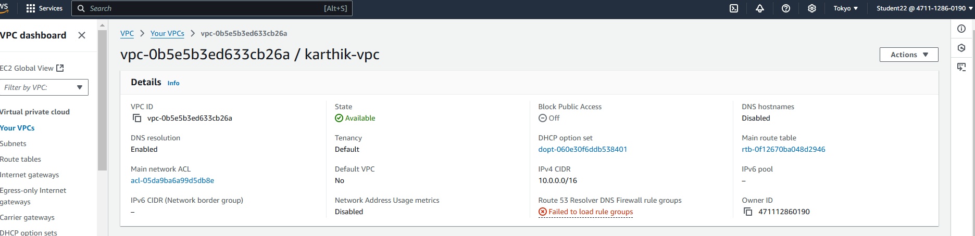

* **Internet gateway is created as karthik-gateway**

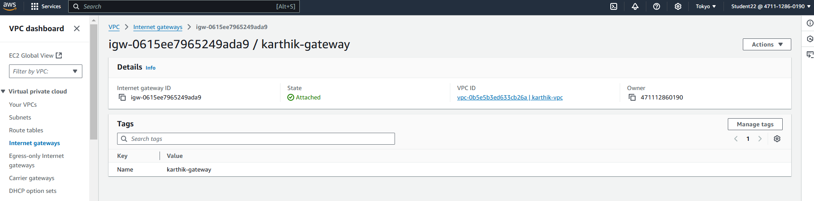

* **Subnet created as karthik-subnet-1**

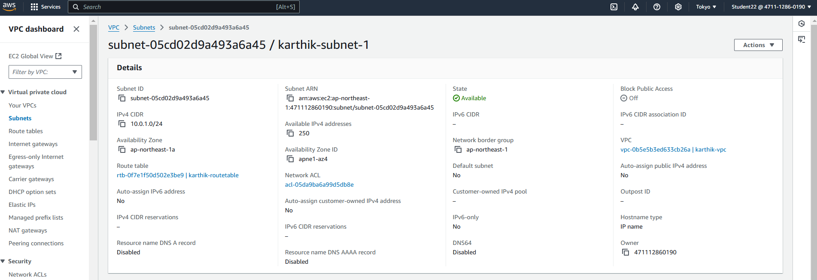

* **Subnet created as karthik-subnet-2**

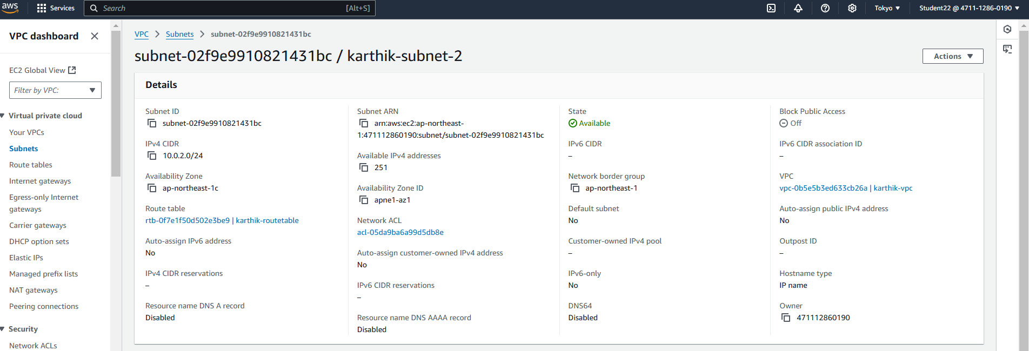

* **Route table is created as karthik-routetable**

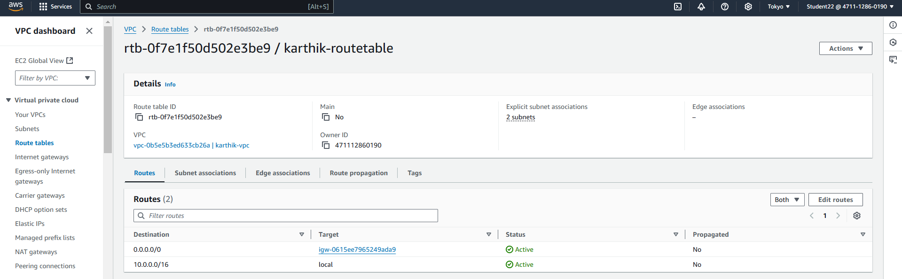

* **Instance server is created as karthik-server**

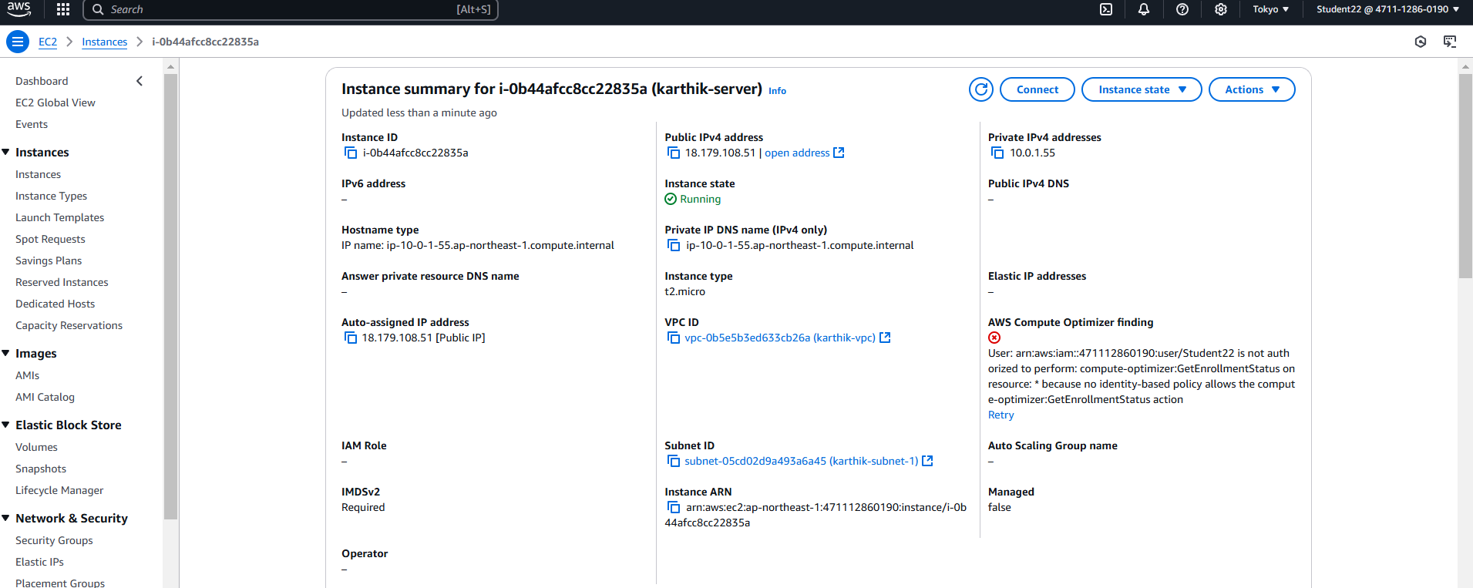

* **Connect to Instance(SSH-Client)**

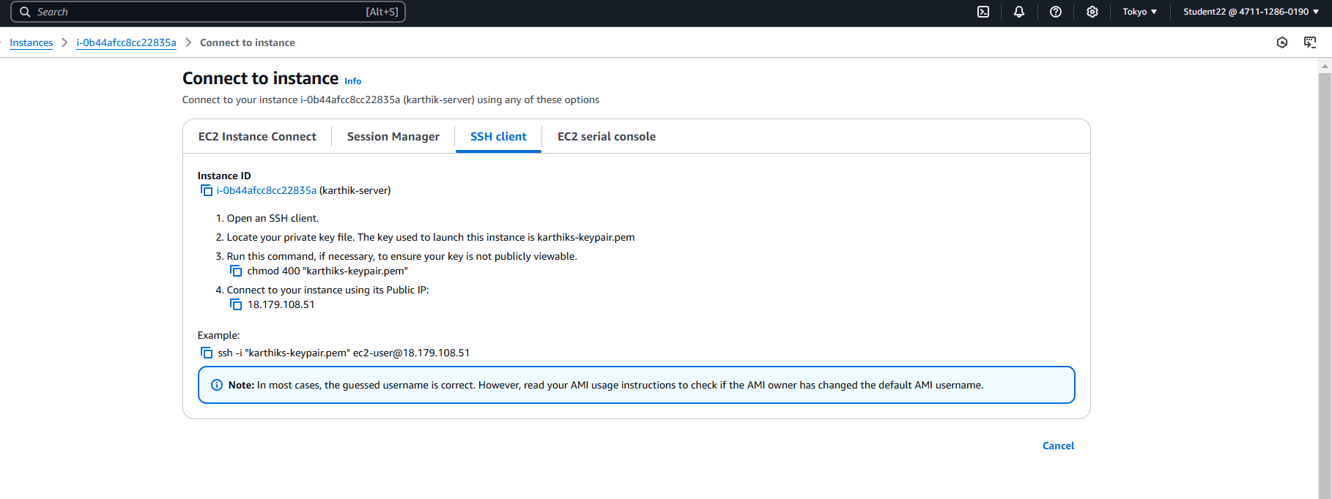

**Command prompt**

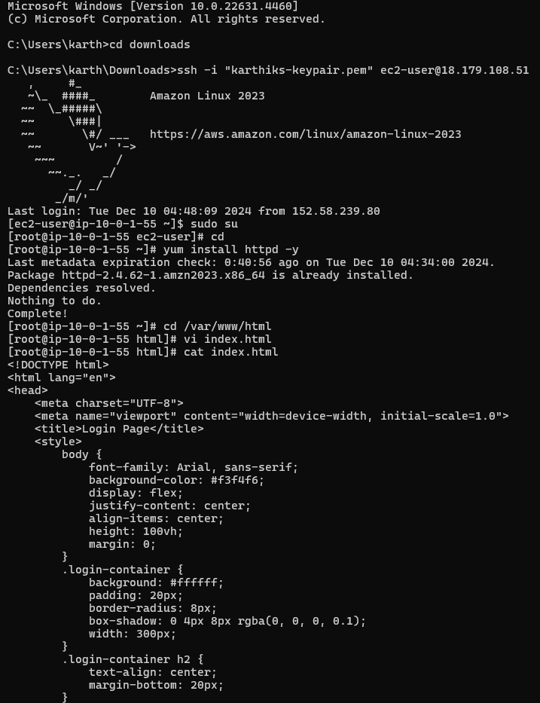

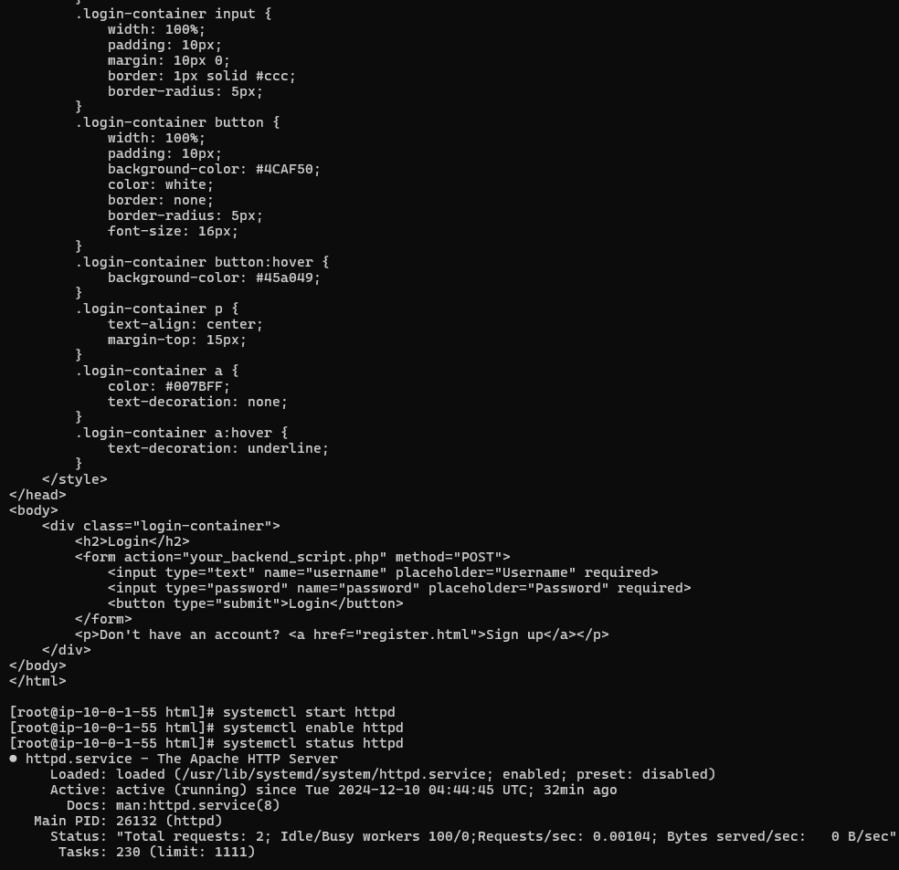

**Final Output**

